HOW TO BOOK PRIVATE LESSONS
PURCHASE PUNCH PASSES
Passes must be purchased through the portal via the swim store. https://app.iclasspro.com/portal/ssaquatics/products/category/passes?viewMode=grid
TO BOOK/PUNCH IN USING PASSES:
- Log into the Customer Portal or Mobile App using your email address and password.
- Navigate to MY ACCOUNT and click on the “Passes” icon for the appropriate student.
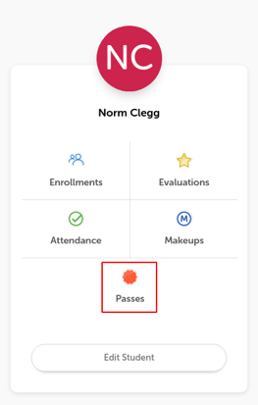
- This will bring up a list of all Punch Passes associated with the selected student. You can expand any collapsed area to view more details.
- USE the small Calendar to select the dates you want to look at for a class.
  - NOTE: The calendar defaults to the current day. Make sure you click on the date at the top to search future dates.
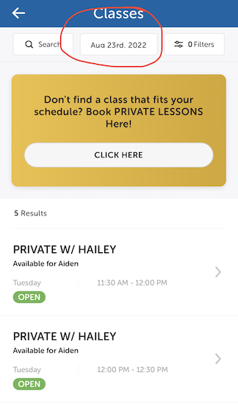
- Once you have located the class for which you wish to redeem your Punch Pass, click on the class and click “Punch In” to complete the enrollment process.
- Repeat steps 4 & 5 until you have punched into all 8 lessons on the dates/times you want.

